Hình 1: Bật máy 2

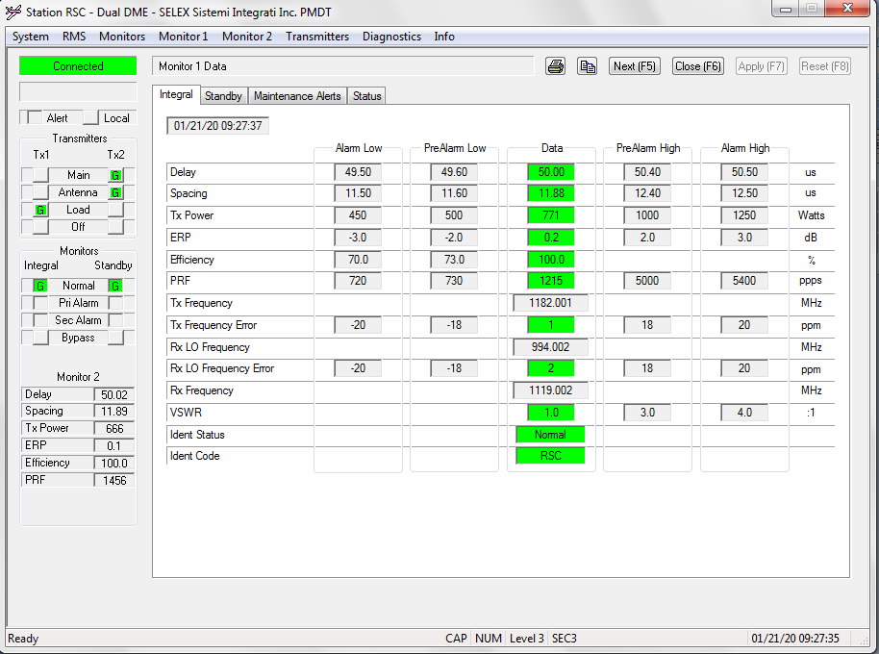

Ban tin:

[09:26:49.196] F8 F8 B0 F0 08 00 00 00 00 34 00 14 01 15 09 1B 23 00 00 80 07 00 00 01 8C 06 39 8A 01 19 BC 8A 13 A5 04 9A 02 E8 03 B0 05 00 00 00 00 00 00 00 00 00 00 06 01 00 00 06 00 00 C8 51 F3 D5 66 D7 15

Dich nghia:

Tx2Ant ON

Tx2Main ON

Tx1On ON

Tx2On ON

DualEquipment ON

eMain

Go condition

Ngay 21 thang 1 nam 20 Gio 9 Phut 27 Giay 35

DME Delay: 5002 us,Spacing: 1189 us,TxPower: 666 Watts,Efficiency :1000 %,PRF: 1456 ppps,ERP: 1

Hình 2 bật local

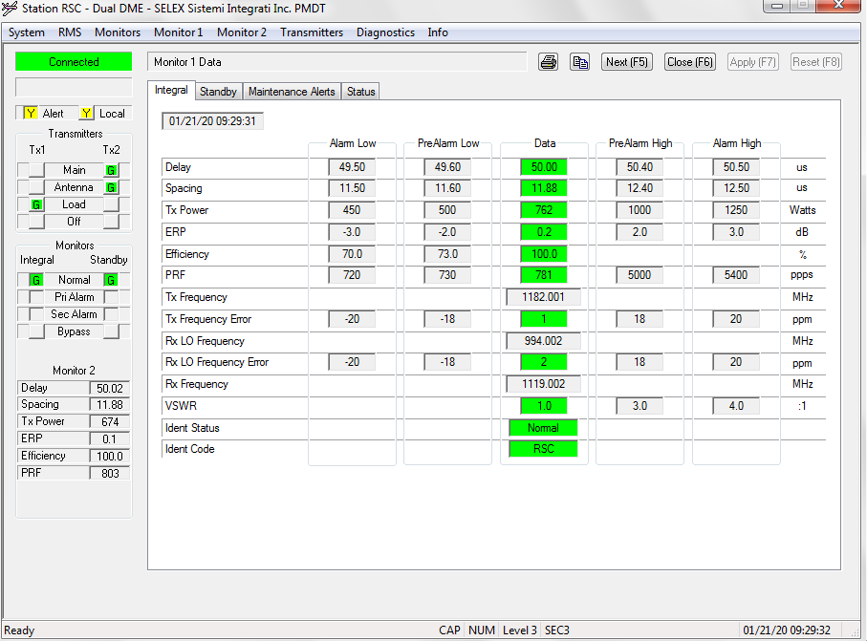

Bật local

[09:29:32.484]F8 F8 B0 F0 08 00 00 00 00 34 00 14 01 15 09 1E 12 00 00 81 07 00 00 11 8C 06 39 8A 01 19 BC 8A 13 A4 04 A2 02 E8 03 2C 03 00 00 00 00 00 00 00 00 00 00 06 01 00 00 06 00 00 42 18 33 D6 66 AB 91

MaintenanceAlert ON

Tx2Ant ON

Tx2Main ON

Tx1On ON

Tx2On ON

DualEquipment ON

LocalControl ON

eMain

No Go condition ALARM

Ngay 21 thang 1 nam 20 Gio 9 Phut 30 Giay 18

DME Delay: 5002 us,Spacing: 1188 us,TxPower: 674 Watts,Efficiency :1000 %,PRF: 812 ppps,ERP: 1

Hình 3 : Tắt local bật máy 1

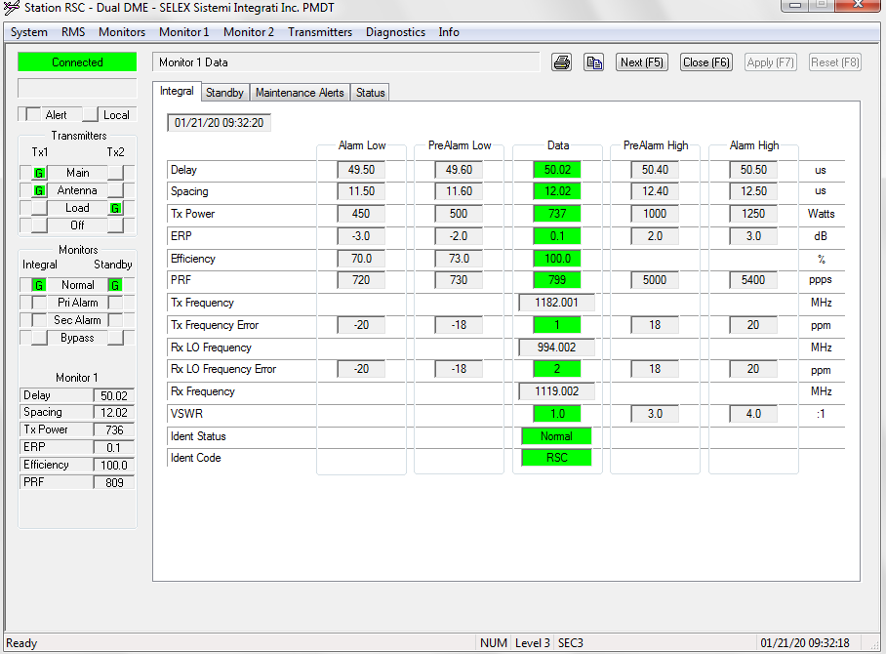

S5 Bypass loi thi van chay dc neu bypass dc dat

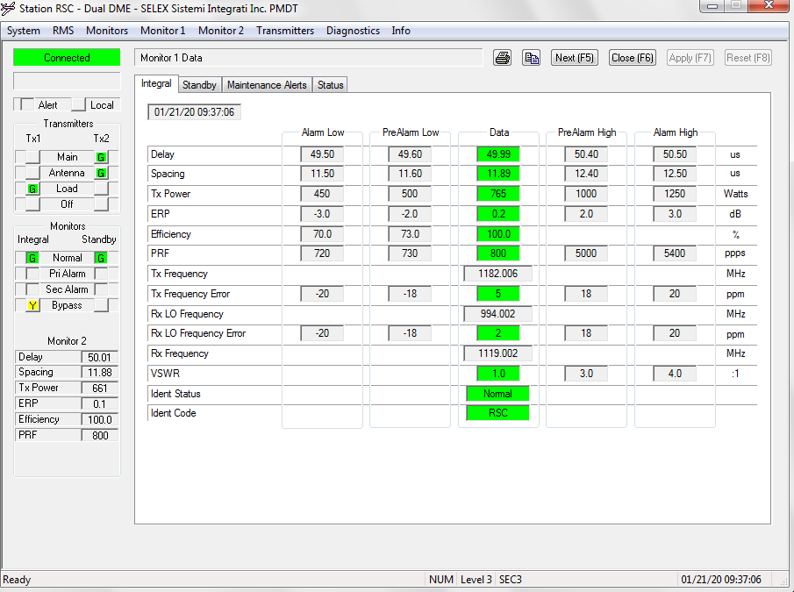

S6 all bypass

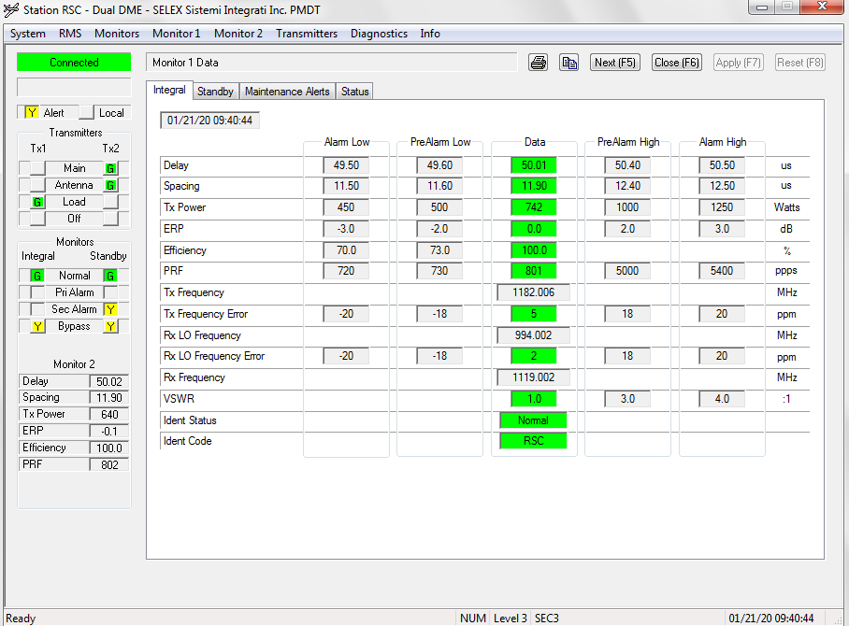

Bypass all sang off 1

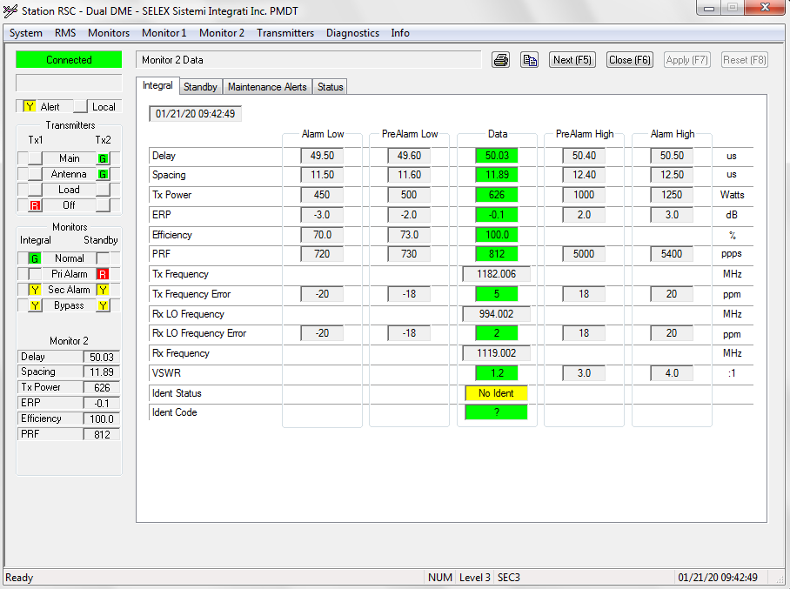

Off 1 sang off 2

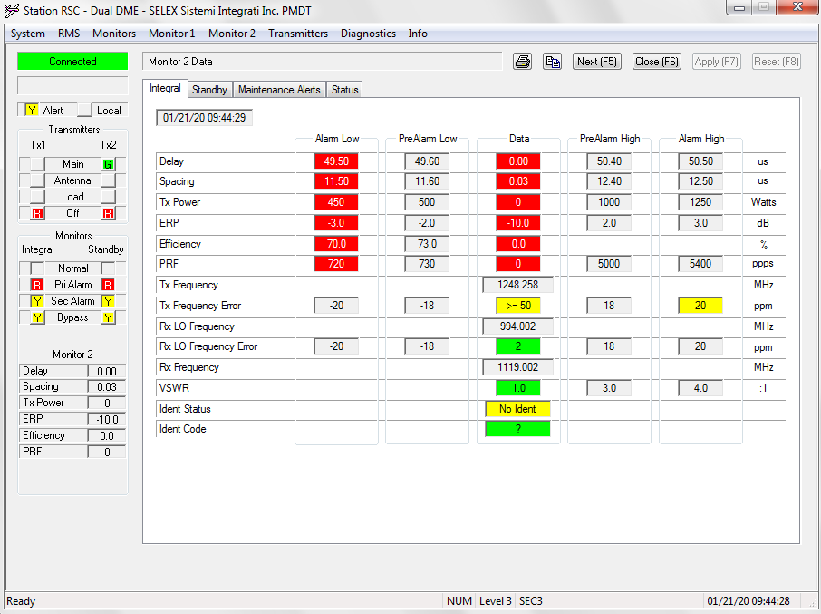

Off may 1

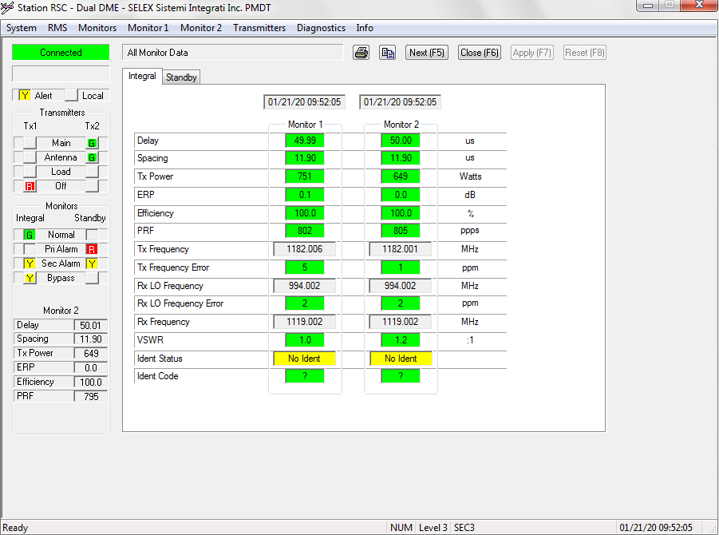

S9 OFF 1 SANG OFFF HET

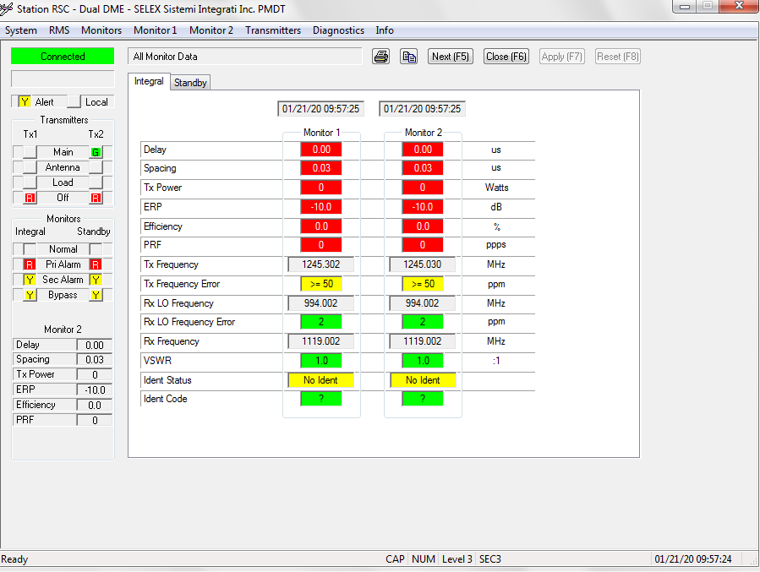

S10

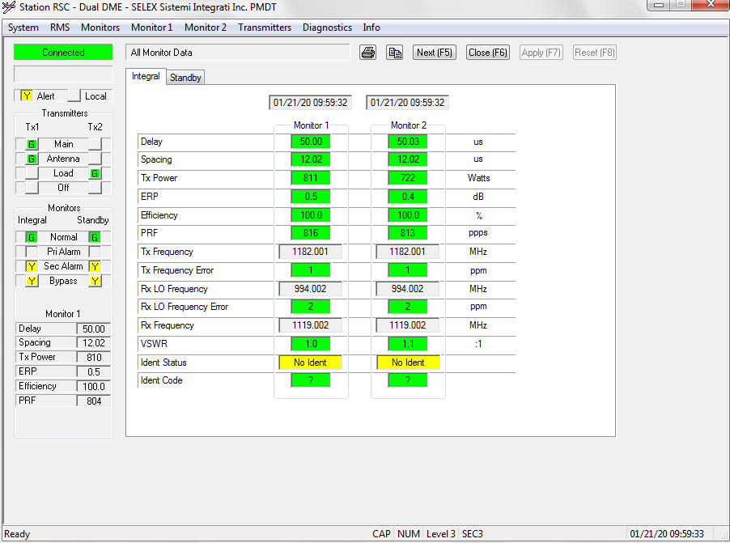

DUOI DAY LA S11

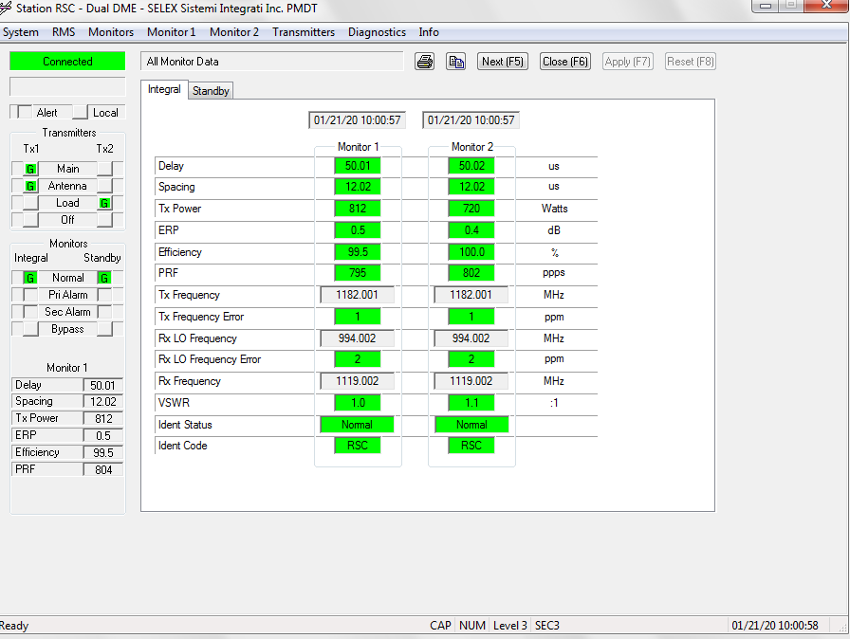

V1 VOR TX1

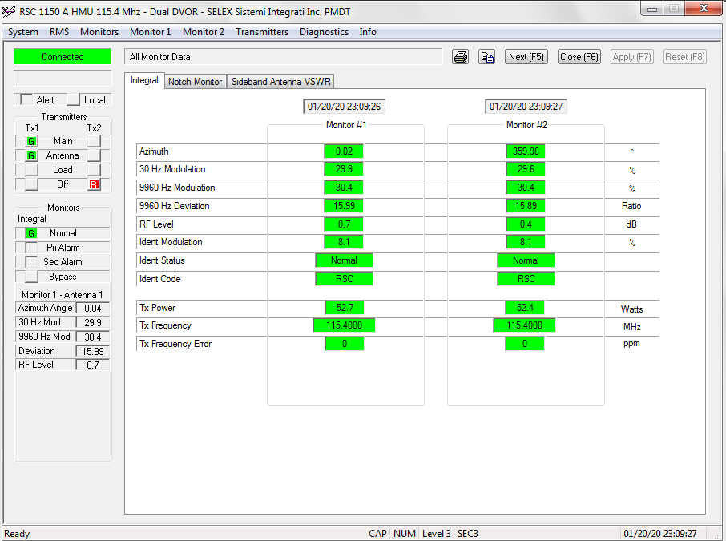

V2 TX2

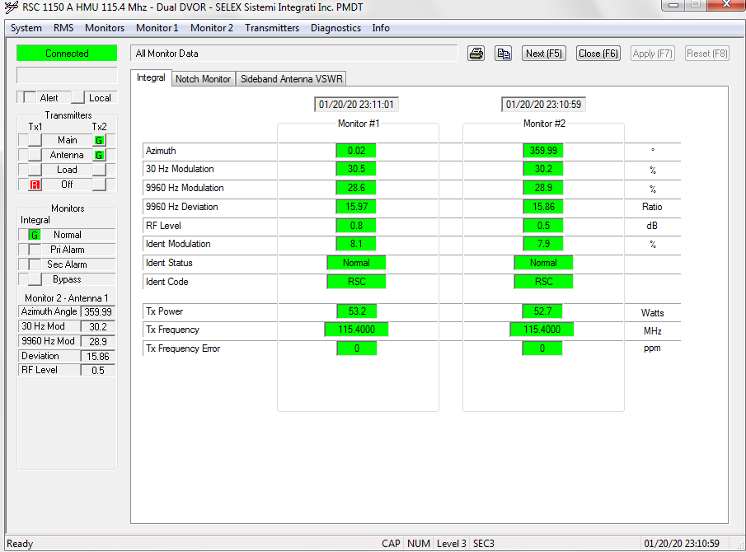

V2[10:27:08.022] F8 F8 C0 F0 08 00 00 00 00 97 00 14 01 14 17 1C 01 00 00 C0 87 00 00 01 88 06 2B 05 09 95 00 00 00 00 00 00 00 00 00 00 00 00 00 00 00 00 00 00 00 00 00 98 8C 30 01 25 01 32 06 02 00 00 00 00 00 00 00 00 00 00 00 00 00 00 00 00 00 00 00 00 00 00 00 00 00 00 00 0C 00 00 00 00 00 00 00 00 00 00 00 00 00 00 00 00 00 00 00 00 00 00 00 00 00 00 00 00 00 00 00 00 00 00 00 00 00 00 00 00 00 00 00 00 00 00 00 00 00 00 00 00 00 00 00 00 00 00 00 00 00 00 7C 00 00 00 43 C8 44 78 6F FB 2D 35 B1 AB

Main Tx2

Ant Tx2

Tx1 OFF

Tx2 ON

DualEquipment ON

Vor eMain

VOR Go condition

Ngay 20 thang 1 nam 20 Gio 23 Phut 28 Giay 1

AzimuthAngle: 35992

Mod30Hz: 304

Mod9960Hz: 293

Deviation :1586

RFlevel: 2

TX2 ROI BAT BYPASS LEN

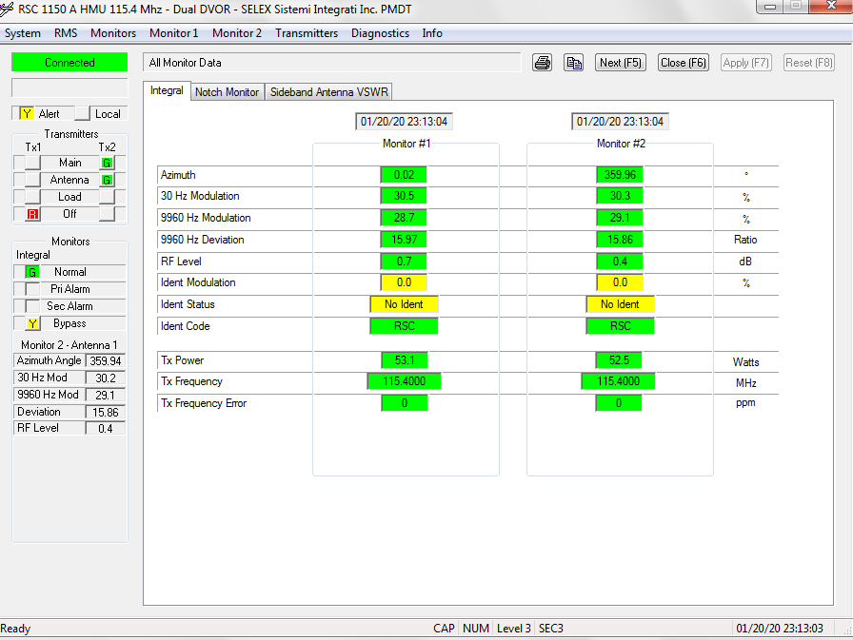

V3[10:25:56.382] F8 F8 C0 F0 08 00 00 00 00 97 00 14 01 14 17 1A 31 00 00 C1 87 00 01 01 98 06 2B 05 09 95 00 00 00 00 00 00 00 00 00 00 00 00 00 00 00 00 00 00 00 00 00 97 8C 30 01 24 01 32 06 02 00 00 00 00 00 00 00 00 00 00 00 00 00 00 00 00 00 00 00 00 00 00 00 00 00 00 00 0C 00 00 00 00 00 00 00 00 00 00 00 00 00 00 00 00 00 00 00 00 00 00 00 00 00 00 00 00 00 00 00 00 00 00 00 00 00 00 00 00 00 00 00 00 00 00 00 00 00 00 00 00 00 00 00 00 00 00 00 00 00 00 1F 00 00 00 47 AC 44 78 6F FB 2D 35 E9 96

Alert

Main Tx2

Ant Tx2

Tx1 OFF

Tx2 ON

DualEquipment ON

IntMonBypass ON

Integral SecAlarm?

13b4 bypass all?

Vor eMain

VOR Go condition

Ngay 20 thang 1 nam 20 Gio 23 Phut 26 Giay 49

AzimuthAngle: 35991

Mod30Hz: 304

Mod9960Hz: 292

Deviation :1586

RFlevel: 2

V4 XONG OFF TAT

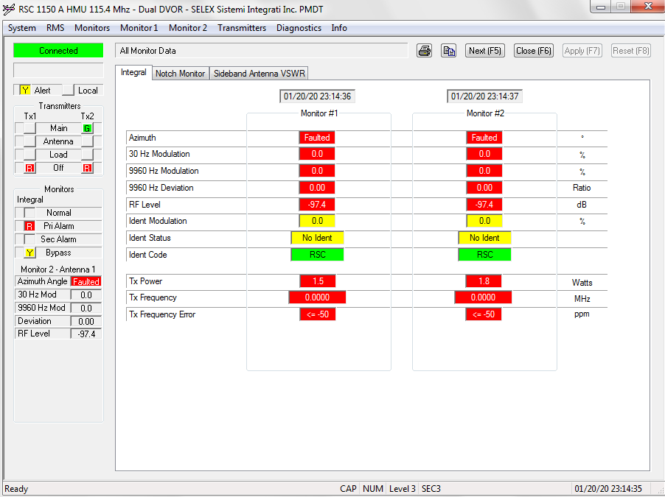

V4[10:23:41.660] F8 F8 C0 F0 08 00 00 00 00 97 00 14 01 14 17 18 22 00 00 C1 A7 40 01 01 93 06 2B 05 09 95 00 00 00 00 00 00 00 00 00 00 00 00 00 00 00 00 00 00 00 00 00 FF FF 00 00 00 00 00 00 32 FC 00 00 00 00 00 00 00 00 00 00 00 00 00 00 00 00 00 00 00 00 00 00 00 00 00 00 00 0E 00 00 00 00 00 00 00 00 00 00 00 00 00 00 00 00 00 00 00 00 00 00 00 00 00 00 00 00 00 00 00 00 00 00 00 00 00 00 00 00 00 00 00 00 00 00 00 00 00 00 00 00 00 00 00 00 00 00 00 00 00 99 00 00 00 A7 77 44 78 6F FB 2D 35 83 F2

Alert

Main Tx1

Ant Tx1

Tx1 OFF

Tx2 OFF

DualEquipment ON

IntMonBypass ON

Integral PriAlarm

Integral SecAlarm?

13b4 bypass all?

eOFF

VOR No Go condition ALARM

Ngay 20 thang 1 nam 20 Gio 23 Phut 24 Giay 34

AzimuthAngle: 65535

Mod30Hz: 0

Mod9960Hz: 0

Deviation :0

RFlevel: -974

XONG BAT VE BINH THUONG

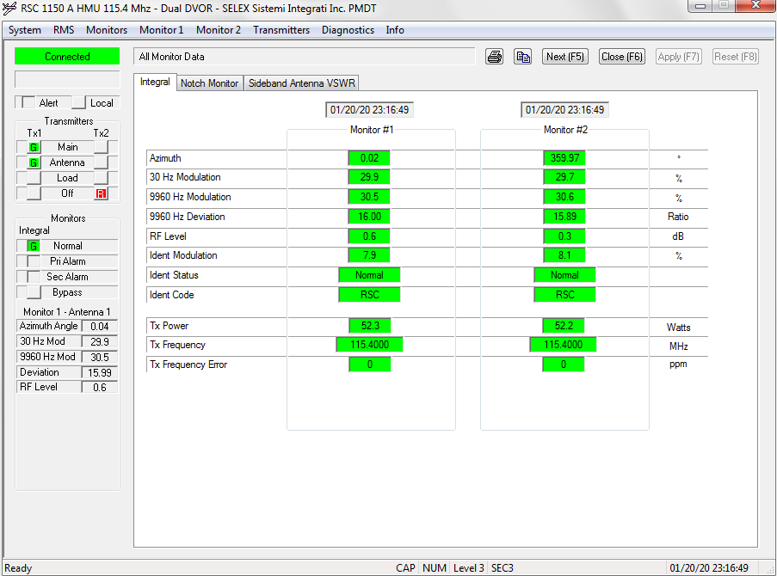

V5[10:20:56.357] F8 F8 C0 F0 08 00 00 00 00 97 00 14 01 14 17 15 31 00 00 C0 A7 00 00 01 87 06 2B 05 09 95 00 00 00 00 00 00 00 00 00 00 00 00 00 00 00 00 00 00 00 00 00 04 00 2C 01 32 01 3F 06 05 00 00 00 00 00 00 00 00 00 00 00 00 00 00 00 00 00 00 00 00 00 00 00 00 00 00 00 00 0E 00 00 00 00 00 00 00 00 00 00 00 00 00 00 00 00 00 00 00 00 00 00 00 00 00 00 00 00 00 00 00 00 00 00 00 00 00 00 00 00 00 00 00 00 00 00 00 00 00 00 00 00 00 00 00 00 00 00 00 00 00 1F 00 00 00 15 37 44 78 6F FB 2D 35 CB DD

Main Tx1

Ant Tx1

Tx1 ON

Tx2 OFF

DualEquipment ON

Vor eMain

VOR Go condition

Ngay 20 thang 1 nam 20 Gio 23 Phut 21 Giay 49

AzimuthAngle: 4

Mod30Hz: 300

Mod9960Hz: 306

Deviation :1599

RFlevel: 5